SuretyMaster Work Plan

Premium Rate Table (Partner Carrier)

*Partner Carrier >> My Organization >> Premium Rate Table* (Fig 1.1)

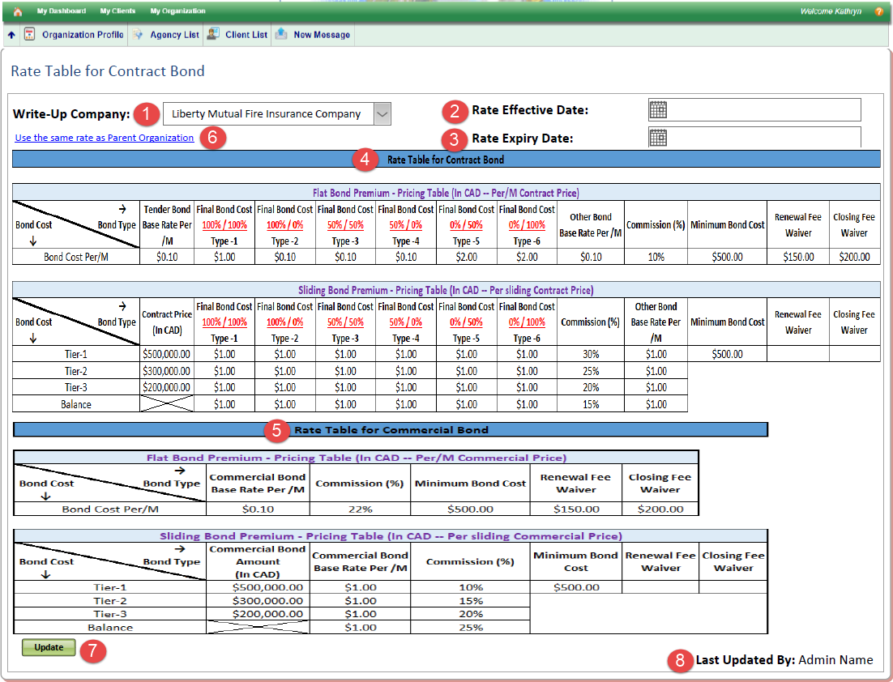

Fig 1.1: Partner Carrier View

1. Select the Write-up of the respective Carrier: Subsequent Rate in the below table will be applicable for the selected Write-up
2. Rate Effective Date: Day from which the Rate is in affect
3. Rate Expiry Date: Day till which the Rate is in affect
4. Rate Table for Contract Bond:
   1. Carrier updating the Flat and Sliding Rate they charge for each Contract Bond or the combinational type of Performance and Payment (Type-1 to Type-8)
      1. Type 1 : 100% / 100% : Performance 100% and Payment 100%
      2. Type 2 : 100% / 0% : Performance 100% Only
      3. Type 3 : 50% / 50% : Performance 100% and Payment 100%
      4. Type 4 : 50% / 0% : Performance 50% Only
      5. Type 5 : 0% / 50% : Payment 50% Only
      6. Type 6 : 0% / 100% : Payment 100% Only
      7. Type 7 : 100% / 50% : Performance 100% and Payment 50%
      8. Type 8 : 50%/ 100% : Performance 50% and Payment 100%
   2. Currently No sliding rate for Other Contract Bond Type except for Final Bond (Performance and Payment). But in future, can scale to include it. Hence system should be ready to scale.
   3. Bond Cost is defined as Bond Rate Per 1000
      1. E.g.: Base Rate for the Bond Cost is $5 Per 1000 = $5/$1000 = 0.5 % of Bond Amount
      2. If Bond Amount is $ 100,000 Then Bond Cost = $ 100,000 * 0.5% = $ 500

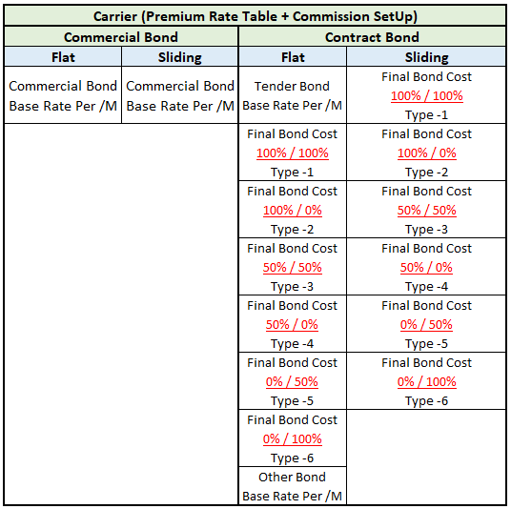

Fig 1.2: Rate/Commission: Possible Bond Type structure

* 1. Carrier defines the number of Tier(s) (*for each Write-up*) and same is applied during Carrier-Agency Relationship
  2. Carrier defines the Commission for the Flat and Sliding Rate for respective Bond Category they offer to the Agency (Broker)

1. Rate Table for Commercial Bond : Same as Contract Bond
2. Use Same Rate as Parent Organization : Allows a Carrier Admin to copy the same rate to its Write-up
   1. Hyperlink shows only when a Write-up is selected from the drop down
   2. It is mandatory for a carrier to Define rates for Global Branch before they can define it for each Write Up.
   3. When Clicked, Values get copied into the Write-up Cells and allowing Admin to modify rates before clicking on Save button
   4. It is mandatory for a carrier to define min of flat rates/Commission for each bond Category
3. Save/Update Button: When defining Rate/Commission for the first time, **Save** button is displayed and If Carrier wants to modify the existing Rates, Admin should click on **Update** Button and enable Edit Mode.
4. Last Update By: Audit Trail display who modified the rate recently.

Premium Rate Table (Traditional Carrier)

*Agency Login >> My Organization >> Premium Rate Table (Traditional Carrier)*

1. For the Traditional Carrier : Agency updates the rate the Traditional Carrier is offering
2. Agency specify the commission the carrier is offering for (affects only the specified Agency)
3. Maybe we can extend the functionality where a report is emailed to the Traditional carrier stating the Commission Agency has entered on behalf of them

Incorporate the Premium Rating Page in the Offer Page  
during the Bond Line approval

1. When Write-up is selected during Bond Line Approval page > Accredited Rating

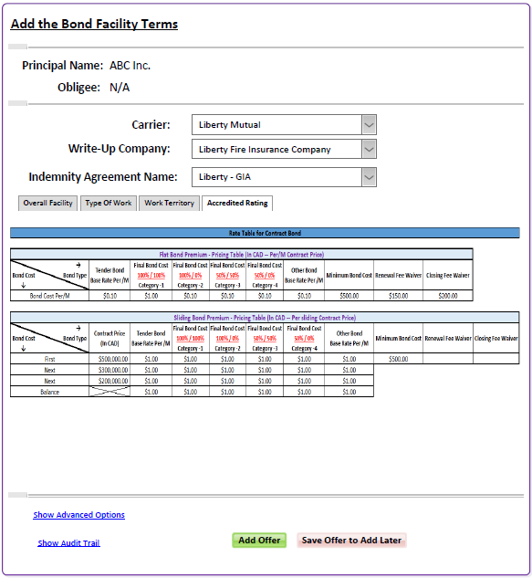

Incorporate the Premium Rating Page in the Account's Bond Line

1. When the Client accepts the Bond Line offered, then the Accredited Rating is visible

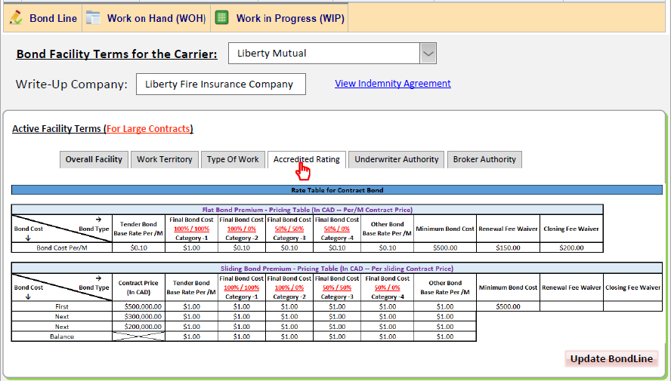

Account's Bond Line

*Agency* >> *Carrier* >> Sub-*Broker* >> *Client* can see Active Bond Line

* Proposal is: When Client Request Easy Path Bond Line, then the Accredited Rating will consist on only Flat Rate/Commission.
  + As Easy Path is for Small Contracts. And Small Contracts usually falls under the first Tier hence it cannot be quoted based on Sliding Rates.

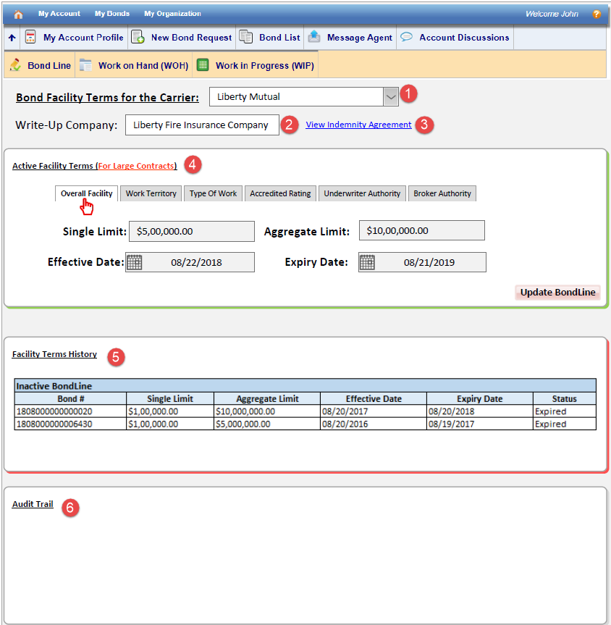

1. Bond Facility Terms of the Carrier:
   1. A Drop down List to select the carrier for which Account has an active Bond Line.
   2. Idle Rule is One Account:: One Bond Line from One Carrier, hence in that case the default carrier should be displayed.
2. Write-up Company: As Bond Line is mapped to one Write-up of a carrier. The Field here Is auto populated and is Read Only
3. View Indemnity Agreement : Hyperlink to view the signed Indemnity Agreement
4. Active Facility Terms : Details of all 6 component constituting the Facility Terms
   1. Overall Facility
      1. Defines Singles Limit and the Aggregate Limit for Contract Bond
      2. Defines Effective Date and Expiry Date for the active Facility Terms
      3. Update : Ability to edit the Overall Facility of ac active Bond Line
   2. Work Territory :
      1. Review the declared *Work Territory* of the client (Part of Bond Line Request)
      2. Underwriter has an ability to add *Work Territory* during approval process
   3. Type of Work:
      1. Review the declared *Type of Work* of the client (Part of Bond Line Request)
      2. Underwriter has an ability to add *Type of Work* during approval process
   4. Accredited Rating
      1. Can see the Flat/Sliding Premium Rates (For Both Contract and Commercial) accepted by the Client.
      2. Can See the Minimum Bond Price for Both Contract and Commercial Bond.
   5. Underwriter Authority
      1. Is read by default from Agency on Record and Carrier’s Relationship
      2. Displays the record of *Lead Underwriter*, *Backup Underwriter 1*, *Backup Underwriter 2*, *Backup Underwriter 3*
      3. Lead Underwriter is responsible to approve any future Contract Bond within the Bond Line tenure.
   6. Broker Authority
      1. List the Agents assigned to the respective accounts.
      2. For Carrier View: Can also see the agreed Commission for Agency on Record.
      3. For Agency on Record : Can see the Commission it gets from Carrier and the Commission it is paying to downline agency (if at all)
      4. Downline Agency : Can see the commission it gets from its upline Agency and commission it is paying to its Downline Agency (If at all)
5. Facility Term History: Shows the Previous Bond Line records for the selected Carrier.
6. Audit Trail : Chronological record sequence of activities that have affected at any time in the Bond line for the specific carrier

Structure for Relationship SetUp and Offer Flow

Sliding Commission should only be between Agency and its Recruiting Carrier, and further downline relationship should have Flat Commission on the Total Bond Cost

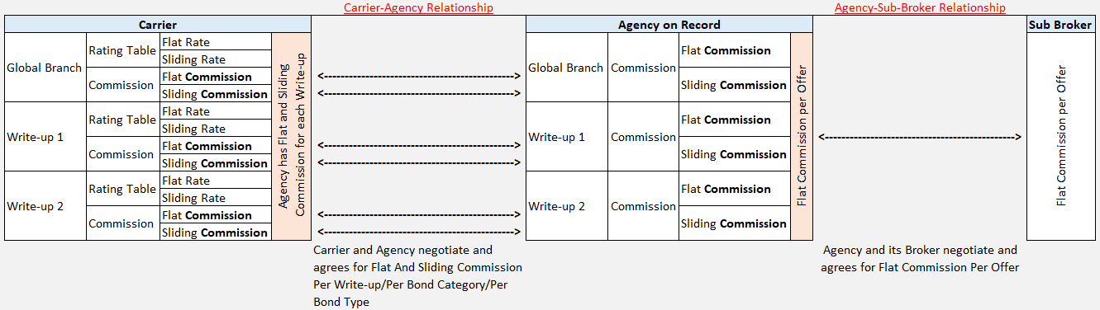



Bond Cost Calculation across layers:

* **Carrier** Adds Bond Cost + (Flat-Sliding) Commission it pays to **Agency on Record**
* **Agency on Record** View Bond Cost + Commission it pays to its downline + Agency fees (Optional)
* **Agency** View Bond Cost + Commission it pays to its downline + Agency fees (Optional)

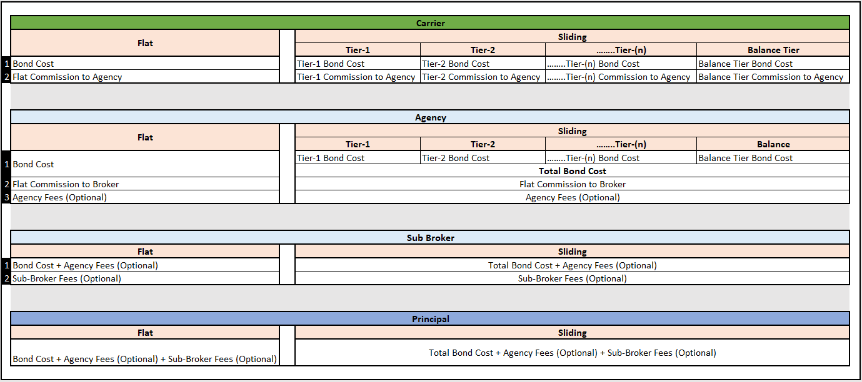

Bond Approval – Contract Bond

For the Contract Bond, Client/Principal can request for

* Bond Line only
* Upgrade from Small Contract Bond Line to Large Contract Bond Line
* Bond Line + Contract Bond
* Upgrade from Small Contract Bond Line to Large Contract Bond Line + Contract Bond
* Contract Only

And Agency/Underwrite can review and add an offer (Approval) for

* Bond Line Only
* Bond Line + Contract Bond
* Upgraded Bond Line Only
* Upgraded Bond Line + Contract Bond
* Contract Bond Only



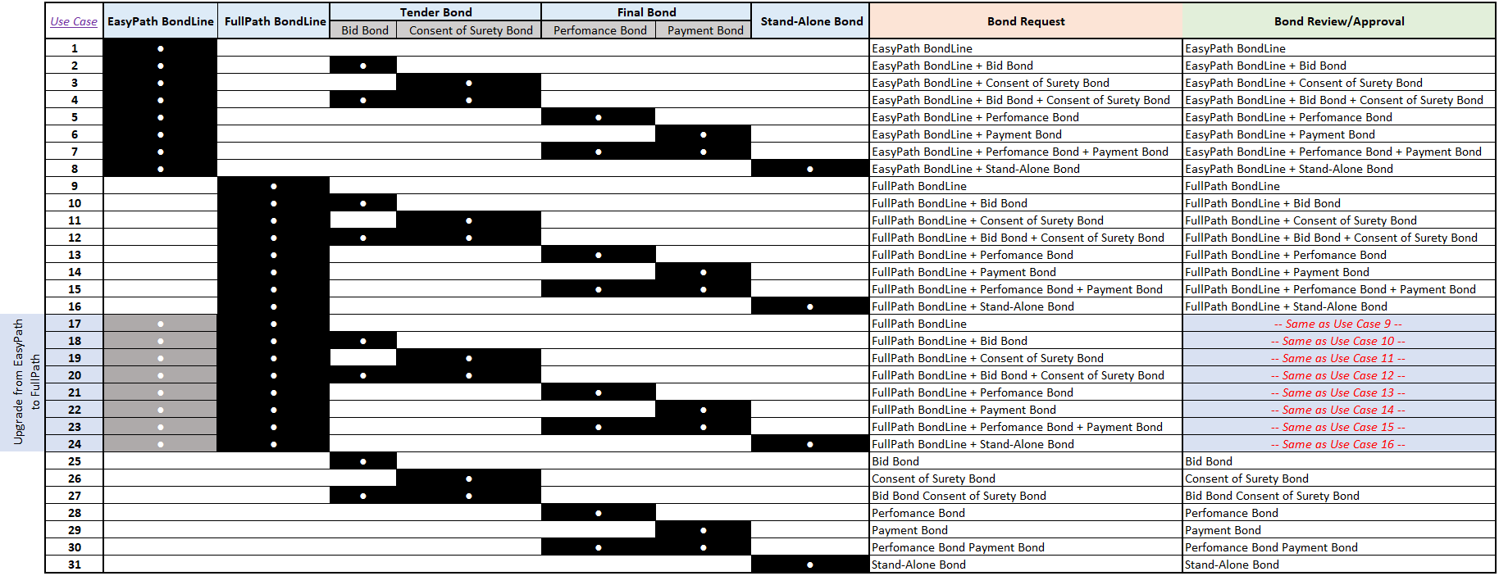

* Mockup Available for the following use case:
  + Underwriter Adding an Offer for the Facility Terms (Bond Line) Only
    - Able to Set Single/Aggregate Limit with the Effective and Expiry Date
    - Accredited Rating is by default is read by Premium Rate Table of the Selected Carrier and its respective Write-up
  + Underwriter Adding an Offer for the One Contract Bond along with the Bond Line
    - Based on the Premium Rate set with the Bond Line in the same approval, Calculation is done automatically for the Contract Bond bundled in the same request.
    - System Rates are auto populated, allowing the Approver to override the Rates
  + Underwriter Adding an Offer for the Two Contract Bond along with the Bond Line
    - Based on the Premium Rate set with the Bond Line in the same approval, Calculation is done automatically for the Contract Bond bundled in the same request.
    - System Rates are auto populated, allowing the Approver to override the Rates
  + Client already has a Bond Line - Underwriter Adding an Offer for the One Contract Bond
    - Accredited Rating is by default is read from Account’s Bond Line
    - System Rates are auto populated, allowing the Approver to override the Rates
  + Client already has a Bond Line - Underwriter Adding an Offer for the Two Contract Bond
    - Accredited Rating is by default is read from Account’s Bond Line
    - System Rates are auto populated, allowing the Approver to override the Rates

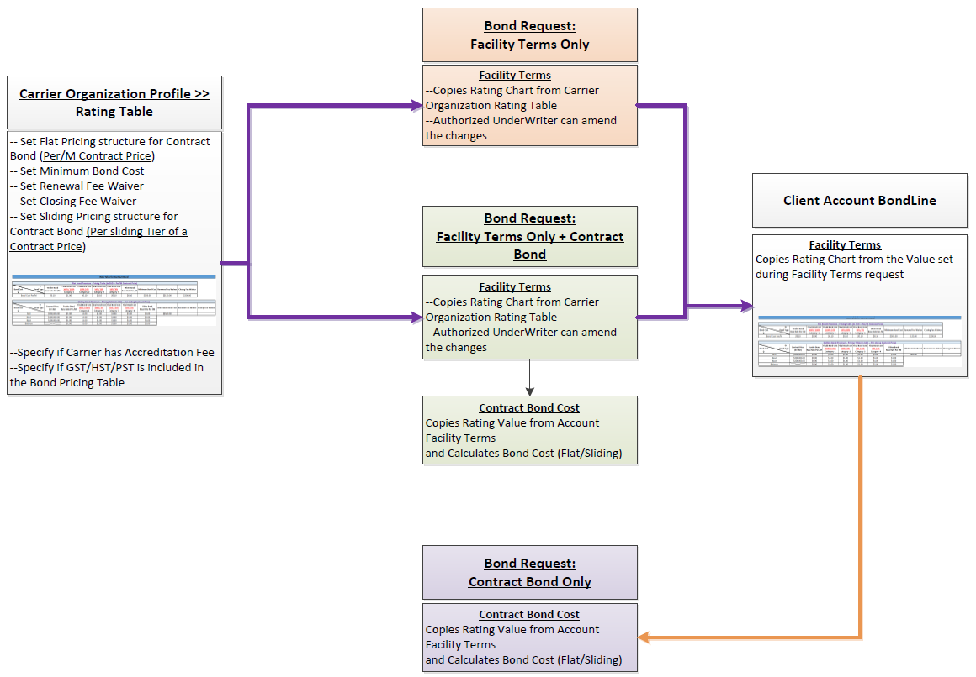

Offer Layout with the new Approval Use-Cases

